Science Megadoc Semester 1

Jacplus 2.2:

**deoxyribonucleic acid (DNA)** and is located within the **nucleus** of your cells.



The location of a gene on a specific chromosome is called its **locus**. Genes that are located on the same chromosome are described as being linked.

Chromosomes: Structure of a chromosome

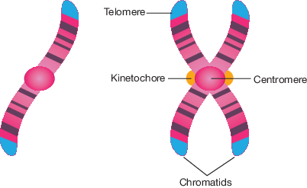

Human Female Gametes are called ova and Male gametes are called sperm.

Mitosis is the type of cell division used to produce sex cells.

Chromosomes are not all the same size.

Males have a pair of XY sex chromosomes and Females have a pair of XX sex chromosomes.

Sometimes a genetic mistake or mutation can occur resulting in more or less of a chromosome.

|  |  |
| --- | --- |
| Autosomes | The name given to non-sex chromosome. |
| Chromosomes | A structure containing genes, located in the nucleus of eukaryotic cells and only visible when the cell is about to divide or is in the process of dividing |
| DNA | A molecule that contains genetic information and is located inside the nucleus of a eukaryotic cell |
| Fertilisation | The fusion of the sperm and the ovum |
| Gametes | Another name for sex cells |
| Gene | A piece of genetic information that contains the instructions for making a particular polypeptide |
| Linked | Genes located on the same chromosome |
| Locus | The location of a gene on a chromosome |
| Nucleus | The location of DNA within your cells |
| Somatic cells | Another name for body cells that are not sex cells |

Autosomes are 44 of the 46 chromosomes and are found in both men and women.

Chromosomes that match with each other are called homologous and those that don’t match are called non-homologous.

The remaining 2 chromosomes are called sex chromosomes. Females possess a pair of X chromosomes (XX) and Males possess x and y chromosomes (XY)

There is an X egg and either a X or Y sperm cell can fertilise it determining your gender.

Karyotype: 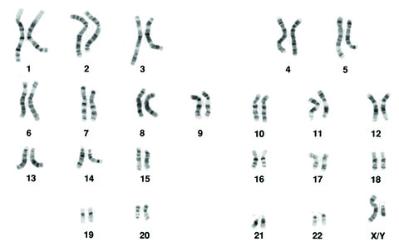

Used to determine chromosomal disorders and can be used to find the gender of a baby as the male sex chromosomes aren’t the same size whereas the female sex chromosomes are.

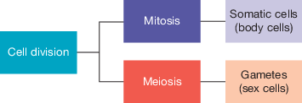

2.3

DNA is made up of repeating units named nucleotides.

Nucleotides consists of: a sugar (deoxyribose in DNA), a phosphate group and a nitrogenous base ( Adenine, Thymine, Guanine, Cytosine.)

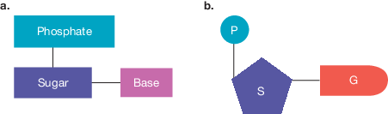

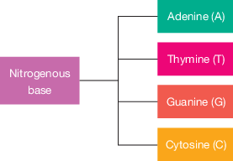

2.4

c02f34

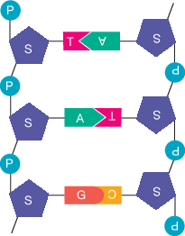DNA forming a double-stranded molecule.

RNA: Like DNA, ribonucleic acid (RNA) is a type of nucleic acid and made up of nucleotides however these nucleotides are different from the nucleotides found in DNA.

Unlike DNA, RNA:

* contains the sugar **ribose** (instead of deoxyribose)
* contains the nitrogenous base uracil (instead of thymine)
* is shorter and single-stranded, so it can fit through a nuclear pore.

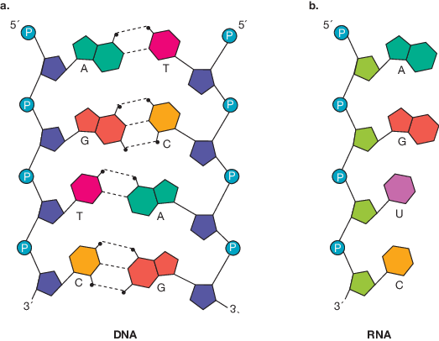

RNA comes in three mains forms: **messenger RNA (mRNA)**, **transfer RNA (tRNA)** and **ribosomal RNA (rRNA)**. All are involved the process of protein synthesis.

DNA can’t fit through the nucleus’ nuclear pores so it creates mRNA through a process called transcription. The RNA then moves to a ribosome in the cytoplasm where the genetic message is translated into a protein through the process called translation.

mRNA passes through the pores of a nuclear membrane into cytoplasm to take its genetic copy of the protein instruction message to ribosomes.

Process of Transciption:

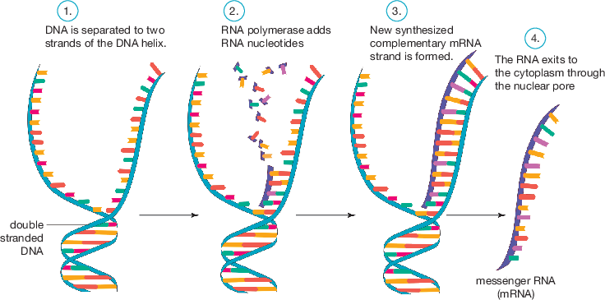

Translation

When mRNA reaches the ribosome the message needs to be translated into a protein. The mRNA is read in groups of three. Each group is called a codon, each codon provides instructions to add a specific amino acid.

tRNA has an anti codon which is able to pair with mRNA.

Genes Active or not:

Some genes have to be active to act and some have to be turned off at different stages in the life of a cell. For example this is why cheek cells don’t grow toenails.

2.7 Dividing to multiply through cell division

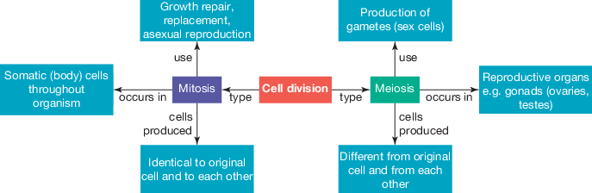

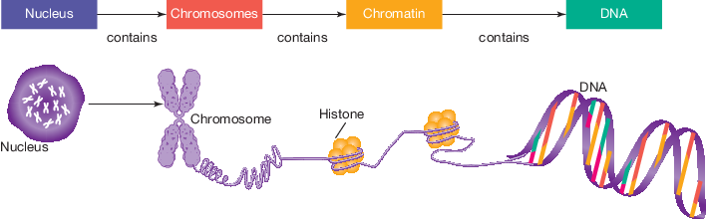

Mitosis Cell Division:

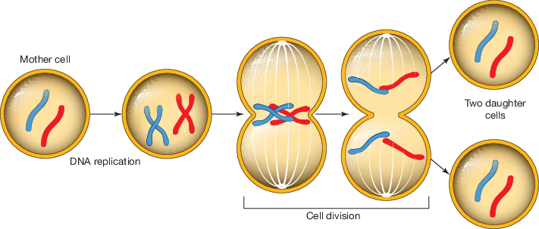

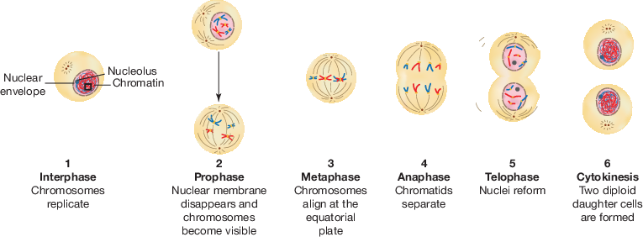

Chromosomes from parents:

Chromosomes carried from the sperm of the father is called paternal chromosomes and chromosomes from the ovum of the mother are called maternal chromosomes.

Meiosis provides sexually reproducing organisms with variation which can provide some with an increased chance of survival compared to others.

2.8 Passing on genes to the next generation

The passing on of characteristics from one generation to the next is called inheritance, the study of inheritance is in the science of genetics.

These characteristics are examples of your phenotype. Phenotype is determined on you genotype and environment. Genotype is determined by genetic information in chromosomes that you receive from the gametes of your parents.

You have a combination of two alleles, 1 from each parent in your genotype

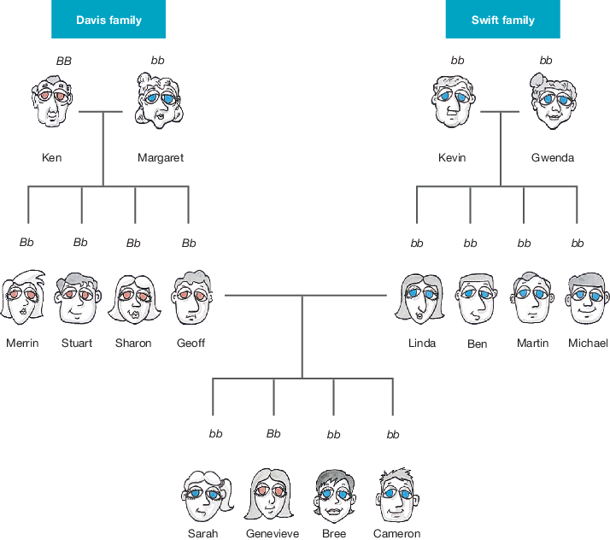

Dominant and recessive genes. Brown eyes is more dominant than the blue eye gene but in the mixage of the two families we can see that Blue eyes starts to become more dominant since the Davis family have the blue eye trait even if not in affect.

If you have BB or bb ( the same alleles) you are homozygous and if they are different Bb the you are heterozygous.

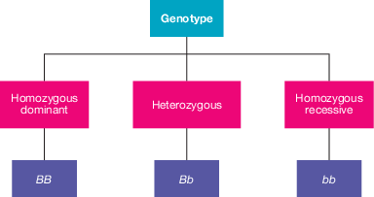

If you are Heterozygous your dominant trait will be presented in your phenotype but your recessive trait could occur in your offspring.

2.9 Punnett squares and predicting inheritance

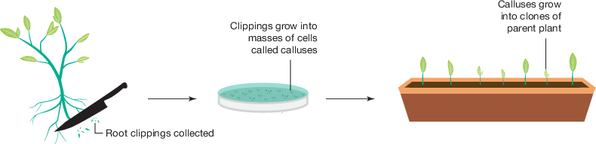

3.5 Natural Selection

Punnett squares

Heterogeneous mice (hyperlink leads to summary)

Cytokinesis

Stages of mitosis

Explaining genetically inherited diseases

RNA converting – the whole process RNA goes through

Labelling question of DNA molecule structure

Multi choice and vocab questions

Extra Revision: Punnet Squares

A punnet square is a square diagram used to predict the possible genotypes of an offspring. The maternal and paternal alleles are put in a two-way table.

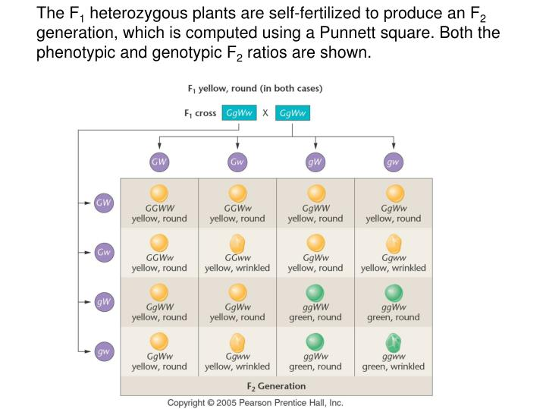

Example of a garden pea punnet square. This particular square is twice the size due to the crossing of two traits (each header has two letters, unlike the punnet square below which has one), which means there will be more outcomes. Notice also that the peas stay yellow when they possess the dominant “G” trait which masks the recessive “g” trait, and only go green if they contain two “g” traits.

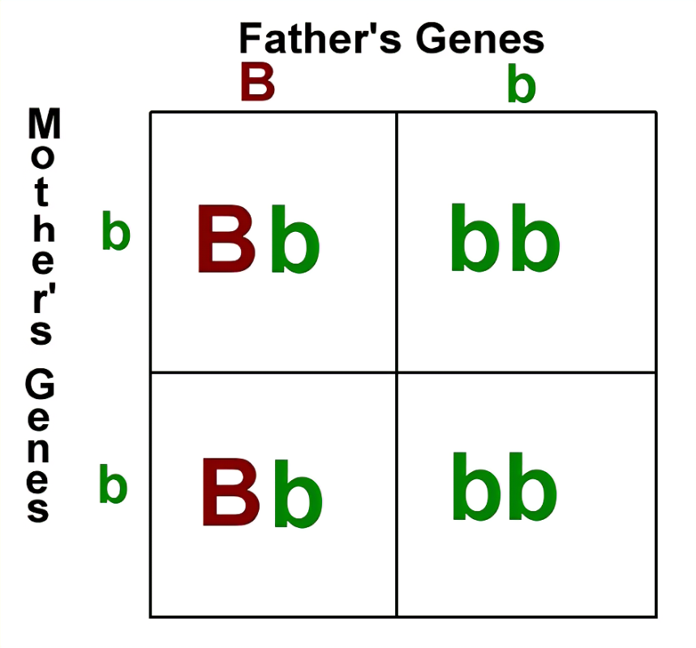

A much simpler punnet square. Note the brown dominant trait “B” and the green recessive traits “b.” Remember that recessive traits are represented with a lowercase letter, while dominant traits are represented by an uppercase letter.

Extra Revision: Labelled structure of DNA

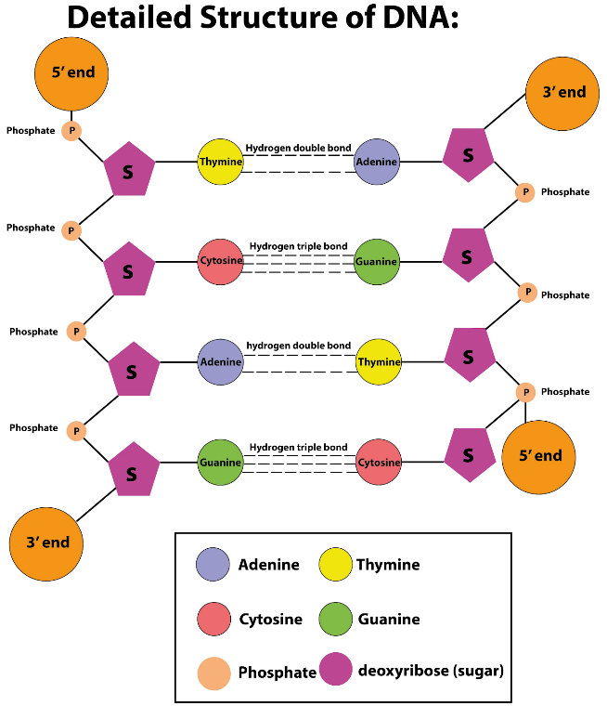

Extra Revision: Meiosis

Meiosis I

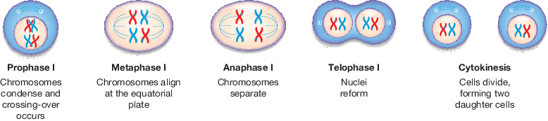

Meiosis II

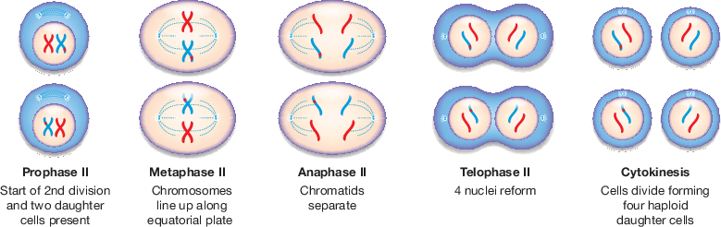

Mitosis, for reference. Note that Interphase doesn’t occur in Meiosis.



Extra Revision: Heterozygous Mice (Summary Below)

*For reference, a genotype refers to the chemical composition of an organism’s DNA, which gives rise to phenotypes. The genotype determines the traits expressed by the phenotype. Phenotypes are observable traits or characteristics of an organism, such as behaviour, colour, size etc.*

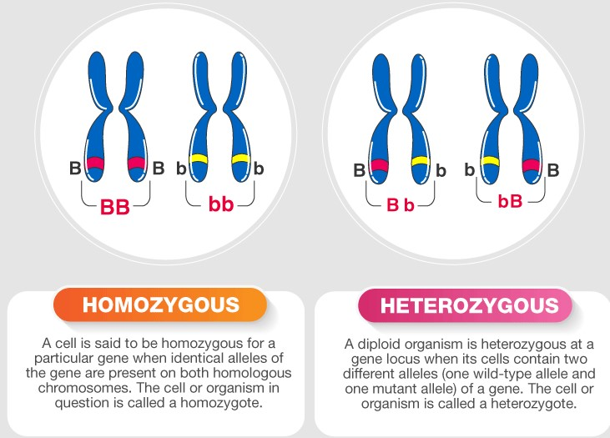

Heterozygous mice, also known as knockout mice or simply genetically modified mice, are mice who have had genes “knocked out” (inactivated) an existing gene by using artificial DNA to replace or disrupt it.

First, the gene which will be knocked out is isolated from the mouse gene library, which is a collection of overlapping DNA fragments (parts of the DNA sequence) that together make up the DNA of the mice. A new DNA sequence is made which is similar to the original sequence and the neighbouring sequence, but is changed enough to make the gene inoperable (not able to be used). More changes are also made to give resistance to the mice, and to complete the sequence.

Embryotic stem cells are isolated from the mouse blastocyst (very young embryo) and are grown in vitro (“in glass,” isolated). The new sequence of DNA is then introduced into the stem cells via electroporation (an electric field is applied to the cells to make the cell allow the passage of molecules through it).

Via homologous recombination, which is a type of genetic recombination in which genetic information is exchanged between two similar or identical molecules of double-stranded or single-stranded nucleic acids, some of the cells will incorporate the new sequence with the knocked out gene into their (the stem cell’s) chromosomes in place of the original gene. The chances of a recombination event are low, so cells are more likely to have the altered gene in one of the two relevant chromosomes, which we refer to as heterozygous.

The stem cells with the knock-out gene are isolated from the rest as to not kill them, as the altered cells have been given resistances as mentioned. These stem cells are then inserted into a mouse blastocyst. Say the stem cells were from a white mouse and have been inserted into the blastocyst of a grey mouse. After the blastocyst is implanted into a female mouse’s uterus, the resulting mouse (the genetically modified, heterozygous mouse made up of cells from both a white and grey mouse) would be classified as a chimera, as it contains different genotypes from the different mice used.

When this mouse breeds, some of its offspring will have one copy of the knocked-out gene in all their cells. These mice do not retain any grey mouse DNA and are not chimeras, however they are still heterozygous.

When these heterozygous offspring are interbred, some of their offspring will inherit the knocked-out gene from both parents; they carry no functional copy of the original unaltered gene (i.e. they are homozygous for that allele).

The whole process of heterozygous mice have helped study and model cancer, obesity, heart disease, diabetes, arthritis, substance abuse, anxiety, aging and Parkinson's disease

To sum it up:

* Heterozygous mice are also known as knockout mice.
* They are mice who have genes “knocked out” aka inactivated.
* Artificial DNA is used to disrupt/replace the gene.
* The process of replacing the gene is as follows:
  + The gene which will be knocked out is separated from the gene library
    - *The gene library is a collection of overlapping parts of the DNA sequence of a mouse.*
  + A new DNA sequence is made, with the following changes:
    - *Changes to make the gene to be knocked out inoperable.*
    - *Given resistances.*
    - *A marker gene, which determine if a nucleic acid sequence has been successfully inserted into an organism's DNA.*
    - *Changes to complete the DNA sequence.*
  + Embryotic stem cells are isolated from the mouse blastocyst.
    - *Blastocysts are very young embryo*
  + The stem cells are grown in vitro.
    - *In vitro means “in glass,” so isolated.*
  + The new DNA sequence is introduced to the cells.
    - *This is done via electroporation (an electric field is applied to the cells to make the cell allow the passage of molecules through it).*
  + Homologous recombination occurs naturally, causing some of the stem cells to incorporate the knocked out gene DNA into their own chromosomes.
    - *Homologous recombination is a type of genetic recombination where genetic information is exchanged between two similar or identical molecules of double-stranded or single-stranded nucleic acids.*
    - *The chances of this actually happening are low, so cells may have the altered gene in only one of their chromosomes, meaning they are heterozygous.*
  + The altered cells are isolated from the unaltered cell to not kill them.
    - *This is because of the resistances which the altered cells have but the unaltered cells don’t.*
  + The cells are then inserted into a mouse blastocyst, which is inserted into a female mouse’s uterus.
  + The resulting mouse has genotypes from the two different mice (the mouse with the knocked out cells, and the mouse which’s blastocyst was used).
    - *The mouse is referred to as a chimera.*
  + The mouse would breed, causing some of its offspring to the knocked out gene in all of their cells.
    - *They have no mouse DNA from the mouse which’s blastocyst was used, nor is it a chimera, but it is still homozygous.*
  + When the offspring are interbred, some of the resulting offspring will receive the knocked out gene from both parents. There is no functional copy of the unaltered gene. They would be homozygous, as both genes are the same.
* Knockout mice have helped study cancer, obesity, heart disease, diabetes, arthritis, substance abuse, anxiety, aging and Parkinson's disease

Extra Revision: Cytokinesis (why this only I have no clue)

Cytokinesis is the part of the cell division process where cytoplasm (all material in a eukaryote cell except for the nucleus) of a single eukaryotic cell divides into two sister cells. It occurs during both mitosis and meiosis I and II.

The cleavage furrow is the ring where the two daughter cells intersect. It closes up to divide the cells.

In mitosis, the two daughter cells are identical to the mother cell. In meiosis, they are not.

Extra Revision: Genetic Disorders

*The below is a diagram showing a disorder/disease related to each chromosome.*

Genetic disorders are health problems caused by a genetic abnormality in the genome (where all of the genetic information of an organism is). The abnormality is a mutation in the genetic code, so if a parent has the mutation, there is a chance that their child will inherit it off them. The chances of the mutation being passed off are increased if both parents have it.

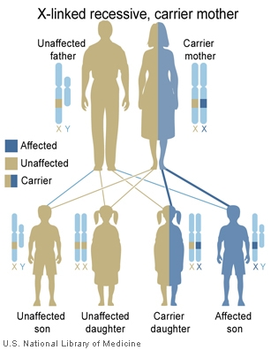 If both parents are carriers, as the graph shows, there is a 25% chance the child will be affected, a 50% chance they’ll carry the mutation but won’t be affected, and a 25% chance they won’t carry the mutation at all.

Extra Revision: Codon Chart

3 nitrogenous bases in sequence are called codons. Codons are used to get specific amino acids.

Below is the chart translating codon to amino acd.

# Glossary

**alleles** alternate forms of a gene for a particular characteristic

**amino acid** an organic compound that forms the building blocks of proteins

**asexual reproduction** reproduction that does not involve fusion of sex cells (gametes)

**autosomes** non-sex chromosomes

**carrier** an individual heterozygous for a characteristic who does not display the recessive trait

**cell** the smallest unit of life and the building blocks of living things

**centromere** section of a chromosome that links sister chromatids

**Chargaff’s rule** a rule that states the pairing of adenine with thymine and cytosine with guanine

**chromatid** one identical half of a replicated chromosome

**chromosomes** tiny thread-like structures inside the nucleus of a cell that contain the DNA that carries genetic information

**clones** genetically identical copies

**codon** sequence of three bases in mRNA that codes for a particular amino acid

**complete dominance** a type of inheritance where traits are either dominant or recessive

**deoxyribonucleic acid (DNA)** a substance found in all living things that contains its genetic information

**deoxyribose** the sugar in the nucleotides that make up DNA

**diploid** the possession of two copies of each chromosome in a cell

**DNA ligase** an enzyme that joins DNA fragments together

**DNA replication** process that results in DNA making a precise copy of itself

**dominant** a trait (phenotype) that requires only one allele to be present for its expression in a heterozygote

**epigenetics** the study of the effect of the environment on the expression of genes

**fertilisation** penetration of the ovum by a sperm

**gametes** reproductive or sex cells such as sperm or ova

**gene** segment of a DNA molecule with a coded set of instructions in its base sequence for a specific protein product; when expressed, may determine the characteristics of an organism

**gene therapy** altering genes with the intention to treat or prevent disease

**genetically modified organism** a organism where the genome has been altered

**genetic engineering** one type of biotechnology that involves working with DNA

**genetic engineers** scientists who use special tools to cut, join, copy and separate DNA

**genetic genealogy** the use of DNA along with other genealogical tests to infer relatedness between individuals

**genetics** study of inheritance

**genome** the complete set of genes present in a cell or organism

**genome maps** maps that describe the order and spacing of genes on each chromosome

**genomics** the study of genomes

**genotype** genetic instructions (contained in DNA) inherited from parents at a particular gene locus

**haploid** the possession of one copy of each chromosome in a cell

**heterozygous** a genotype in which the two alleles are different

**holobiont** a host and their associated microbiota

**hologenome** the sum of genetic information of a host and its microbiota

**homologous** chromosomes with matching centromeres, gene locations, sizes and banding patterns

**homozygous** a genotype in which the two alleles are identical

**homozygous dominant** a genotype where both alleles for the dominant trait are present

**homozygous recessive** a genotype where both alleles for the recessive trait are present

**induced mutation** a mutation of DNA in which the cause can be identified

**inheritance** genetic transmission of characteristics from parents to offspring

**karyotype** an image that orders chromosomes based on their size

**kinetochore** a region on a chromosome associated with cell division

**linkage analysis** use of markers to scan the genome and map genes on chromosomes

**locus** position occupied by a gene on a chromosome

**maternal chromosomes** chromosomes from the ovum

**meiosis** cell division process that results in new cells with half the number of chromosomes of the original cell

**messenger RNA (mRNA)** single‑stranded RNA transcribed from a DNA template that then carries the genetic to a ribosome to be translated into a protein

**mitosis** cell division process that results in new genetically identical cells with the same number of chromosomes as the original cell

**molecular genetics** study of genetics at a molecular level

**monohybrid ratio** the 3:1 ratio of a particular characteristic for offspring produced by heterozygous parents, controlled by autosomal complete dominant inheritance

**monomers** molecules that are the building blocks of larger molecules known as polymers

**monosomy** a condition where there is only one copy of a particular chromosome instead of two

**mutagen** agent or factor that can induce or increase the rate of mutations

**mutations** changes to DNA sequence, at the gene or chromosomal level

**nitrogenous base** a component of nucleotides that may be one of adenine, thymine, guanine, cytosine or uracil

**nucleic acids** molecules composed of building blocks called nucleotides, which are linked together in a chain

**nucleotides** compounds (DNA building blocks) containing a sugar part (deoxyribose or ribose), a phosphate part and a nitrogen-containing base that varies

**nucleus** roundish structure inside a cell that contains DNA and acts as the control centre for the cell

**ova** female reproductive cells or eggs

**paternal chromosomes** chromosomes carried in the sperm

**pedigree chart** diagram showing the family tree and a particular inherited characteristic for family members

**phenotype** characteristics or traits expressed by an organism

**point mutation** a mutation at one particular point in the DNA sequence, such as a substitution or single base deletion or insertion

**polymers** molecules made of repeating subunits of monomers joined together in long chains

**prenatal screening** testing a fetus during pregnancy to detect any abnormalities

**proteins** molecules, such as enzymes, haemoglobin and antibodies made up of amino acids

**Punnett square** a diagram used to predict the outcome of a genetic cross

**recessive** a trait (phenotype) that will only be expressed in the absence of the allele for the dominant trait

**recombinant DNA** a molecule of DNA that contains fragments from more than one source

**recombinant DNA technology** technology that can form DNA that does not exist naturally, by combining DNA sequences that would not normally occur together

**restriction enzymes** enzymes that cut DNA at specific base sequences (recognition sites)

**restriction fragment length polymorphisms (RFLPs)** variations in the lengths of DNA fragments in individuals with different alleles of a gene

**retroposons** segments of DNA that can break off a chromosome and paste themselves elsewhere in the genome

**ribonucleic acid (RNA)** a type of nucleic acid that contains ribose sugar

**ribose** the sugar found in nucleotides of RNA

**ribosomal RNA (rRNA)** a special type of RNA that forms the structure of ribosomes

**ribosome** organelle found in the cells of all organisms in which translation occurs

**sex chromosomes** chromosomes that determine the sex of an organism

**sex-linked inheritance** an inherited trait coded for by genes located on sex chromosomes

**sexual reproduction** reproduction that involves the joining together of male and female gametes

**single nucleotide polymorphisms (SNPs)** genetic differences between individuals that can result from single base changes in their DNA sequences

**sister chromatids** identical chromatids on a replicated chromosome

**somatic cells** cells of the body that are not sex cells

**sperm** male reproductive cell

**spontaneous mutation** a mutation of DNA that cannot be explained or identified

**symbiotic** a very close relationship between two organisms of different species

**telomerase** enzyme involved in maintaining and repairing a telomere

**telomere** a cap of DNA on the tip of a chromosome that enables DNA to be replicated safely without losing valuable information

**transcription** the process by which the genetic message in DNA is copied into a mRNA molecule

**transfer RNA (tRNA)** molecules located in the cytosol that transport specific amino acids to complementary mRNA codons in the ribosome

**transgenic organism** an organism with genetic information from another species in its genome

**translation** an inherited trait coded for by genes located on sex chromosomes

**transposition** the ability of a gene to change position on the chromosome

**transposons** a section of chromosome that moves about the chromosome within a cell through the method of transposition

**triplet** a sequence of three nucleotides in DNA that can code for an amino acid

**trisomy** a condition where there are three copies of a particular chromosome instead of two

**variation** differences between cells or organisms

**zygote** a cell formed by the fusion of male and female reproductive cells

Chapter 3 – Evolution

**absolute age** number of years since the formation of a rock or fossil

**absolute dating** determining the age of a fossil and the rock in which it is found using the remaining amount of unchanged radioactive carbon

**adaptation** a feature that aids in the survival of an organism

**adaptive radiation** when divergent evolution of one species results in the formation of many species that are adapted to a variety of environments

**alleles** alternative forms of a gene for a particular characteristic

**allopatric** a type of speciation where populations are separated by a geographical barrier

**analogous structures** body structures that perform a similar function but may not have a similar basic structure

**angiosperms** plants that have flowers and produce seeds

**artificial selection** the process in which humans breed animals or plants in such a way to increase the proportion of desired traits

**binomial system of nomenclature** system devised by Carolus Linnaeus giving organisms two names, the genus and another specific name

**biodiversity** total variety of living things on Earth

**biogeography** geographical distribution of species

**carbon dating** a radiometric dating technique that uses an isotope of carbon-14 to determine the absolute age of fossils

**catastrophism** the theory that the Earth was changed only by sudden catastrophes rather than evolutionary processes

**chloroplasts** membrane-bound organelles which are the site of photosynthesis

**chromosomes** tiny thread-like structures inside the nucleus of a cell that contain the DNA that carries genetic information

**coevolution** the process in which two species evolve in partnership so that they depend on each other

**comparative anatomy** exploring similarities and differences in the anatomical structures of various species

**comparative embryology** exploring similarities and differences between embryos of various species

**continental drift** the theory that the continents of Earth have moved to different locations over time

**convergent evolution** tendency of unrelated organisms to acquire similar structures due to similar environmental pressures

**crossing over** exchange of alleles between maternal and paternal chromosomes

**deforestation** the process of clearing trees to convert the land for other uses

**divergent evolution** when a population is divided into two or more new populations that are prevented from interbreeding

**DNA hybridisation** a technique that can be used to compare the DNA in different species to determine how closely related they are

**ecosystem** community of living things that interact with each other and with the environment in which they live

**emigration** a type of gene flow in which an individual leaves a population

**endosymbiosis** a process that describes the evolutionary origin of mitochondria and chloroplasts within eukaryotic cells

**endosymbiotic theory** a theory that can be used to describe the evolutionary origin of mitochondria and chloroplasts in eukaryotic cells

**eras** divisions of geological time defined by specific events in the Earth’s history, divided into periods

**eukaryotic cells** cells that possess membrane-bound organelles such as a nucleus and mitochondria; e.g. animals, plants fungi and protoctistans

**evolution** the process in which traits in species gradually change over successive generations

**extinction** complete loss of a species when the last organism of the species dies

**fault** a break in a rock structure causing a sliding movement of the rocks along the break

**fold** a layer of rock bent into a curved shape, which occurs when rocks are under pressure from both sides

**fossils** evidence of life in the past

**gametes** reproductive or sex cells such as sperm or ova

**gene flow** the movement of individuals and their alleles between populations

**gene pool** the total genetic information of a population, usually expressed in terms of allele frequency

**genetic diversity** variation in genes between members of the same species

**genetic drift** changes in allele frequency due to chance events such as floods and fires

**Gondwana** one of the continents formed when Pangaea broke up, part of which became Australia

**gradualism** the theory that suggests the Earth’s geological features were due to the cumulative product of slow but continuous processes

**half-life** time taken for half the radioactive atoms in a sample to decay; that is, change into atoms of a different element

**homologous structures** body structures that can perform a different function but have a similar structure due to their evolutionary origin

**homology** similar characteristics that result from common ancestry

**introduced species** a species not native to an ecosystem brought in from another ecosystem

**isotopes** atoms of the same element that differ in the number of neutrons in the nucleus

**Laurasia** one of the continents formed when Pangaea broke up

**meiosis** cell division process that results in new cells with half the number of chromosomes of the original cell

**mitochondria** membrane-bound organelles where cellular respiration occurs

**molecular biology** the study of the structure and composition of molecules within a cell

**mutation** change to DNA sequence, at the gene or chromosomal level

**natural selection** process in which organisms better adapted for an environment are more likely to pass on their genes to the next generation

**palaeontology** study of organisms of the geological past as represented by their fossil remains

**Pangaea** a giant continent that existed 200 million years ago and broke into two parts called Laurasia and Gondwana

**periods** subdivisions of geological time, divided into epochs

**phyletic evolution** when a population of a species progressively changes over time to become a new species

**plate tectonics** theory describing the movement of parts of the Earth’s crust, called plates, and explaining the events at the boundaries between the plates

**population** members of one species living together in a particular place at the same time

**potassium–argon dating** a radiometric dating technique based on the measure ratio of potassium-40 to argon-40

**radiometric dating** a technique in which radioactive substances are used to calculate the age of rocks or dead plants and animals

**relative age** age of a rock compared with the age of another rock

**relative dating** method of dating that determines the age of a rock layer by relating it to another layer using superposition and the fossils contained

**selective pressures** factors that contribute to selecting which variations will provide the individual with an increased chance of surviving over others

**species** taxonomic unit consisting of organisms capable of mating and producing viable and fertile offspring

**species diversity** the number of different species within an ecosystem

**uniformitarianism theory** a theory based on the concept that the Earth is changed by natural forces that occur gradually over time

**variation** differences between cells or organisms

Chapter 7 – Global Systems

**acid rain** rainwater, snow or fog that contains dissolved chemicals that make it acidic

**atmosphere** the layer of gases around the Earth

**biodiversity** total variety of living things on Earth

**biomes** regions of the Earth divided according to dominant vegetation type

**biosphere** the life-support system of the Earth, containing the atmosphere, lithosphere, hydrosphere and biota

**biota** the living things within a region or geological period

**cellular respiration** the chemical reaction involving oxygen that moves the energy in glucose into the compound ATP

**climate sensitivity** the measure of temperature change in the climate, dependent on the amount of carbon dioxide released into the atmosphere

**convection currents** process of heat transfer in gases and liquids in which lighter and hotter materials rise, and cooler and denser materials sink

**deforestation** the process of clearing trees to convert the land for other uses

**desertification** the process in which fertile regions become more dry and arid

**enhanced greenhouse effect** an intensification of the greenhouse effect caused by an increase in greenhouse gases in the atmosphere

**extinction** complete loss of a species when the last organism of the species dies

**geosequestration** the process that involves separating carbon dioxide from other flue gases, compressing it and piping it to a atmosphere

**global warming** the observed rise in the average near-surface temperature of the Earth

**greenhouse effect** a natural effect of the Earth’s atmosphere trapping heat, which keeps the Earth’s temperature stable

**greenhouse gases** gases found in the atmosphere that contribute to the greenhouse effect, trapping the Sun’s heat

**hydrosphere** Earth’s water from the surface, underground and air

**ice cores** samples of ice extracted from ice sheets containing a build-up of dust, gases and other substances trapped over time

**Kyoto Protocol** an international agreement with the goal of reducing the amount of greenhouse gases produced by industrialised nations

**landfills** areas set aside for the dumping of rubbish

**lithosphere** the outermost layer of the Earth; includes the crust and uppermost part of the mantle

**ozone layer** a layer in the stratosphere, about 25 km above Earth, that has high concentrations of ozone gas

**palaeoclimate** the climate at a specific point in geological history

**Paris Agreement** an agreement between nations to reduce the global average temperature increase

**permafrost** ground that is frozen for at least two continuous years

**photosynthesis** food-making process in plants that takes place in chloroplasts, and uses carbon dioxide, water and energy from the Sun

**radiant heat** heat transferred by radiation, such as from the Sun to the Earth

**remote sensing** data collection about Earth’s biosphere completed from space by devices such as satellites

Theories of evolution

Charles Darwin was a biologist

Biosphere

Element Cycles

Green house effect

Solar radiation